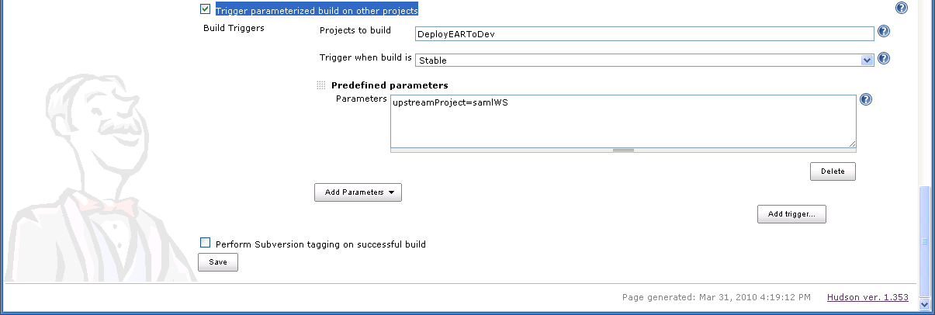
DeployEARToDev job is being triggered from this maven2 job
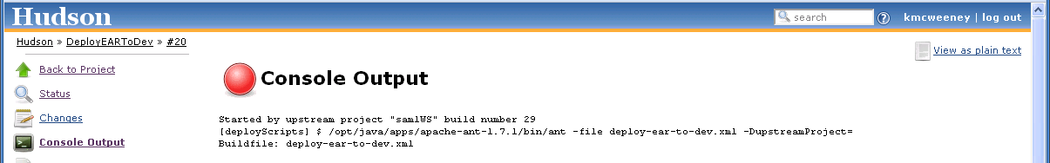
The call to the job does not populate the upstreamProject property

